EMBEDDED SYSTEMS LAB
FAROOQ AHMAD EXPERIMENT # 12
17L-4407 LAB REPORT # 12
EL-7B

INTRODUCTION TO REAL TIME OPERATING SYSTEM

INTRODUCTION
In this lab session, we were introduced to the real time operating system (RTOS). A real-time operating system (RTOS) is an operating system (OS) intended to serve real-time applications that process data as it comes in, typically without buffer delays. Processing time requirements (including any OS delay) are measured in tenths of seconds or shorter increments of time.
In this lab, we will be using the freeRTOS. FreeRTOS is a class of RTOS that is designed to be small enough to run on a microcontroller – although its use is not limited to microcontroller applications. FreeRTOS provides the core real time scheduling functionality, inter-task communication, timing and synchronization primitives only. This means it is more accurately described as a real time kernel, or real time executive. FreeRTOS can easily be used with any microcontroller such as TM4C.
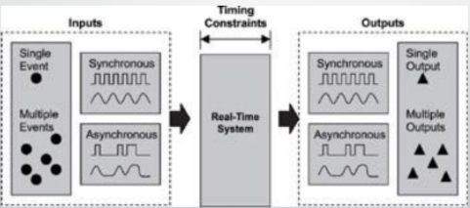

OBJECTIVE
The course learning objective of this lab session was to learn how to use FreeRTOS with TM4C.

PROCEDURE
Create a new task and add it to the list of tasks that are ready to run.
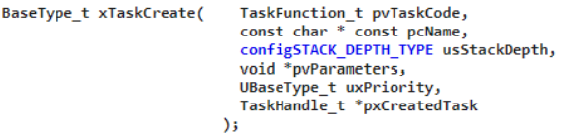
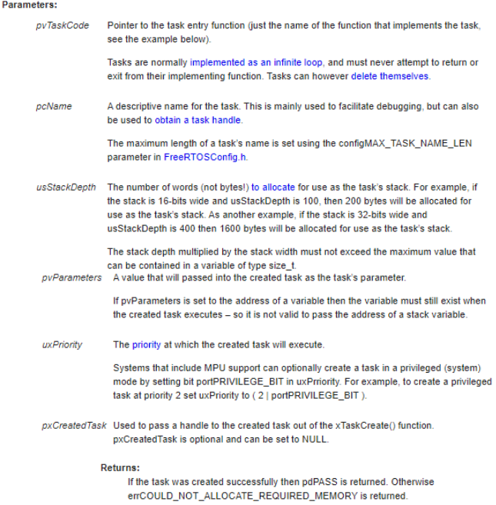
Delay a task for a given number of ticks.
The actual time that the task remains blocked depends on the tick rate. The constant portTICK_PERIOD_MS can be used to calculate real time from the tick rate – with the resolution of one tick period
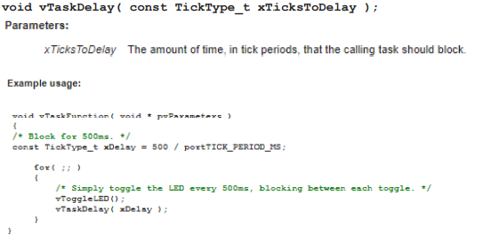

ISSUES
There were no issues.

CONCLUSION
This experiment was performed successfully. In this lab session, it was learnt how to use freeRTOS for real time operating system with tm4c. A real-time system is a time-bound system which has well-defined, fixed time constraints. Processing must be done within the defined constraints or the system will fail. They either are event-driven or time-sharing. Event-driven systems switch between tasks based on their priorities, while time-sharing systems switch the task based on clock interrupts.
A real-time system is a time-bound system which has well-defined, fixed time constraints. Processing must be done within the defined constraints or the system will fail. They either are event-driven or time-sharing. Event-driven systems switch between tasks based on their priorities, while time-sharing systems switch the task based on clock interrupts.

APPLICATIONS
Real-time systems are used in:
1. Airlines reservation system.
2. Air traffic control system.
3. Systems that provide immediate updating.
4. Used in any system that provides up to date and minute information on stock prices.
5. Defense application systems like RADAR.
6. Networked Multimedia Systems
7. Command Control Systems 8. Internet Telephony
9. Anti-lock Brake Systems
10. Heart Pacemaker
FreeRTOS supports all general kernel objects including task, semaphore, queues, messages etc. The demo project we are going to use in this lab follows a structure where each and every task or object has its own header file. Different attributes are defined in their own header file.

POST LAB
The task with the highest priority runs first
• Real-time kernels generally support 256 priority levels, in which 0 is the highest and 255 the lowest.
• Some kernels appoint the priorities in reverse order, where 255 is the highest and 0 the lowest.

